## Regarding Models

* Smaller Chips seem to be the norm. Going as high as max. 240x240. Larger = more RAM and GPU-RAM
* Different sizes should result in different kernel sizes?

## Regarding Loss

* SSMI inconsistent? As seen here, completely empty images doesn’t have significantly different SSMI than closer image. Alignment issues? Shiftnet?

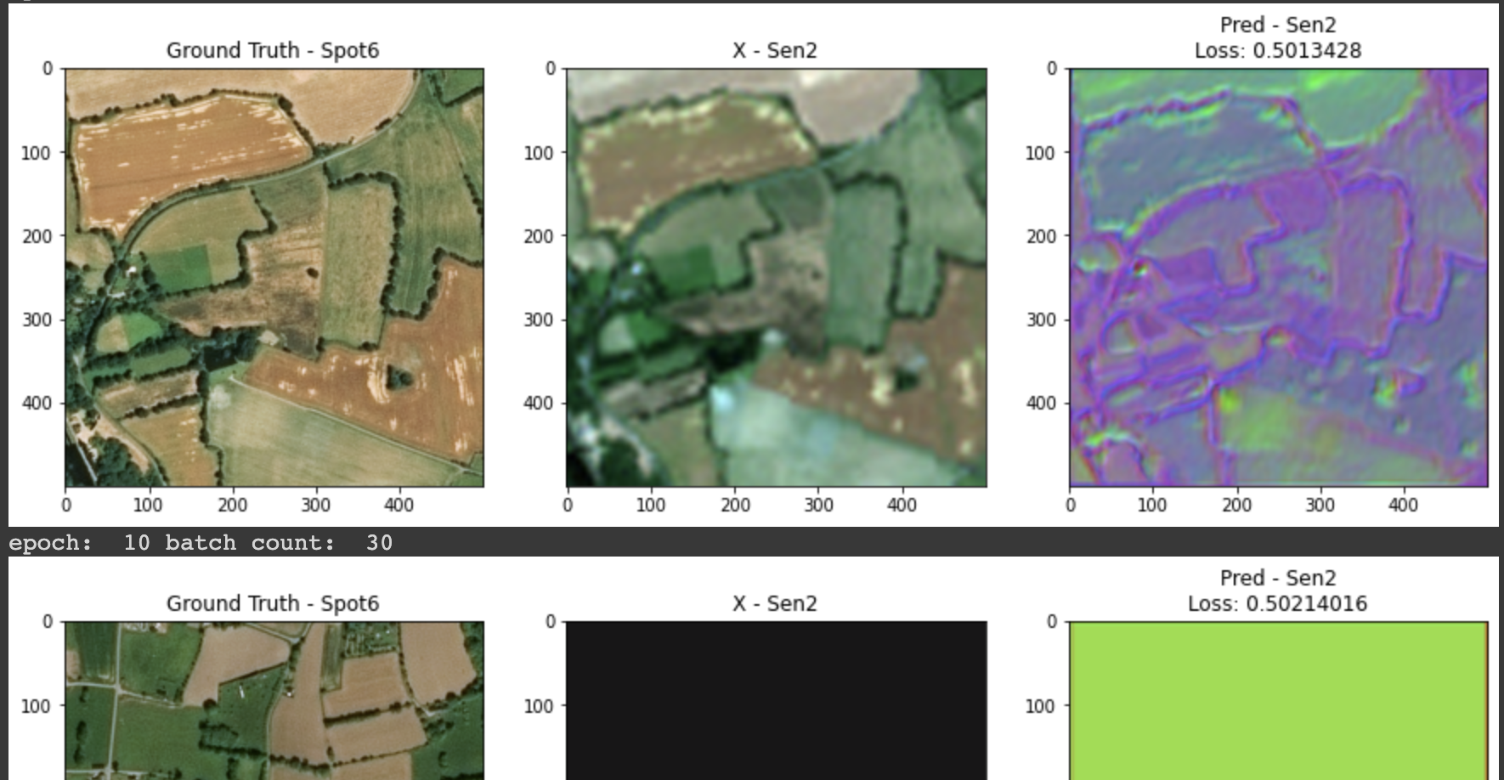

* Also, ssim and mae independently seem not to work too well, maybe unifying them helps? SSIM-> changes in texture while mae/mse changes in color